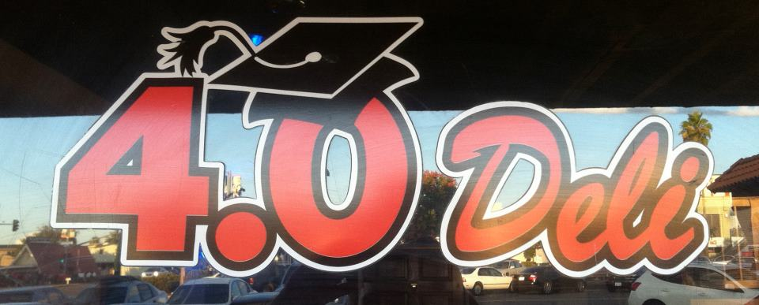
Society of Women Engineers FUNDRAISER!

MONDAY April 21 – FRIDAY April 25

Support Society of Women Engineers! Come to 4.0 Deli between Monday April 21 and Friday April 25 (all day long) and bring this flyer with you! All proceeds go to supporting SWE. Eat a sandwich, Drink a beer, Support an Engineer!

Society of Women Engineers FUNDRAISER!

MONDAY April 21 – FRIDAY April 25

Support Society of Women Engineers! Come to 4.0 Deli between Monday April 21 and Friday April 25 (all day long) and bring this flyer with you! All proceeds go to supporting SWE. Eat a sandwich, Drink a beer, Support an Engineer!

Society of Women Engineers FUNDRAISER!

MONDAY April 21 – FRIDAY April 25

Support Society of Women Engineers! Come to 4.0 Deli between Monday April 21 and Friday April 25 (all day long) and bring this flyer with you! All proceeds go to supporting SWE. Eat a sandwich, Drink a beer, Support an Engineer!

Society of Women Engineers FUNDRAISER!

MONDAY April 21 – FRIDAY April 25

Support Society of Women Engineers! Come to 4.0 Deli between Monday April 21 and Friday April 25 (all day long) and bring this flyer with you! All proceeds go to supporting SWE. Eat a sandwich, Drink a beer, Support an Engineer!

