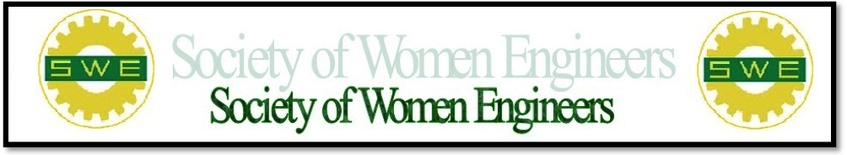
Meeting Minutes
SWE-SDSU Student Section General Body Meeting
Tuesday April 16, 2013

- Welcome (3:30PM)
- Introduce the new SWE officers for (2013-2014)
- Present (2012-2013) officers with awards
- Membership:Fiscal year for SWE is from July 1st to June 30th so sign up this summer to become an official member of SWE for next year!
- Raffle: Those who have attended previous meetings or bring a friend to the meeting are entered in a raffle to win a free SWE SDSU shirt!

- Upcoming events
  - May 7, 2013 at 3:30 pm: end of the semester meeting will be a relay/ game and trivia day to relax and have fun before finals start.
  - SWEeter Futures April 20th 12pm-5pm: Those who are going can carpool, talk to Rachelle or Lauren
  - EWB: Wine for Water August 31st @ the Birch Aquarium
  - SWE: Evening of Professional Development October 17th @ SDSU Alumni Center
(3:50 – 4:20 Speaker)
- Speaker Introduction
  - Melissa Valdovinos:
- Works for the state of California Water quality Control Board
- SDSU graduate and former SWE officer
- Teaches air pollution engineering and solid waste management at SDSU
- Email: mvaldovinos@mail.sdsu.edu

